Setting up xbox in Raspberry Pi

Reference: https://tutorials-raspberrypi.com/raspberry-pi-xbox-360-controller-wireless/

Remotely connect to raspberry pi\
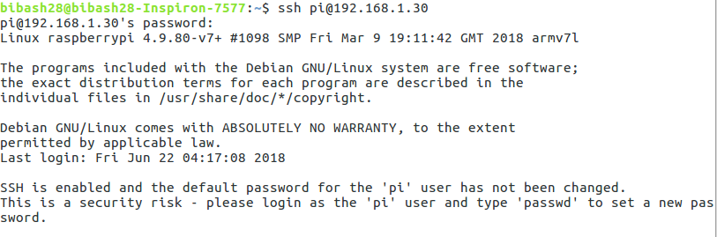
Install driver

Connect Reciever and check if it is detected
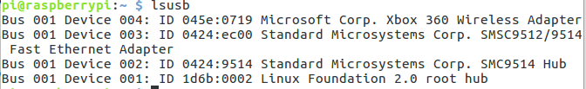
Turn the controller ON and check if its is detected
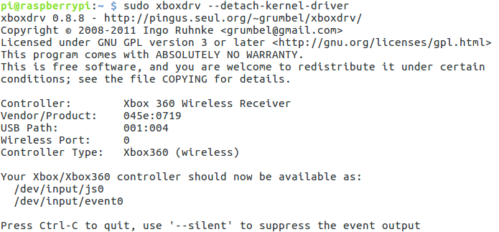

Using Xbox 360 Controller as Raspberry pi Mouse
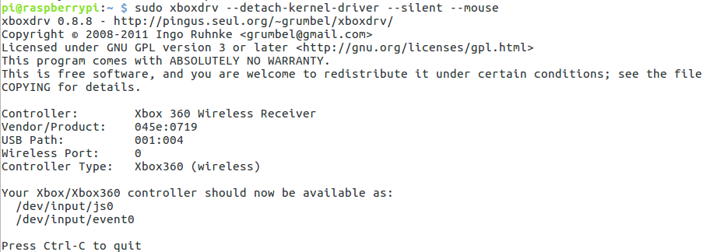
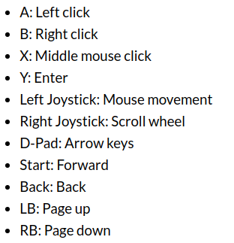
The following assignment of the keys for use as a mouse applies:

Use the Xbox 360 controller to start scripts and commands

Now I am using already created library

Xbox folder will be created. You can use xbox.py as library. You can also see the sample program

